**Your Name: Purnabhishek Sripathi**

**Grading Policy: In order to get credit for each screenshot,** you **MUST** have the repository named as ***BAN540_YourLastName*** with**Consumer_YourLastName** and**ProblemSolving_LinearRegression_YourLastName** in it. The repository and data files **MUST** be clearly shown in your screenshot as my examples below. You will get ZERO for that particular screenshot which doesn’t show them clearly.

**Note:** “YourLastName” in this document refers to your own last name. Don’t literally type in “YourLastName” to name any of your repositories/processes/dataset files.

**Screenshot #1 (6 points)**

**Screenshot #2 (6 points)**

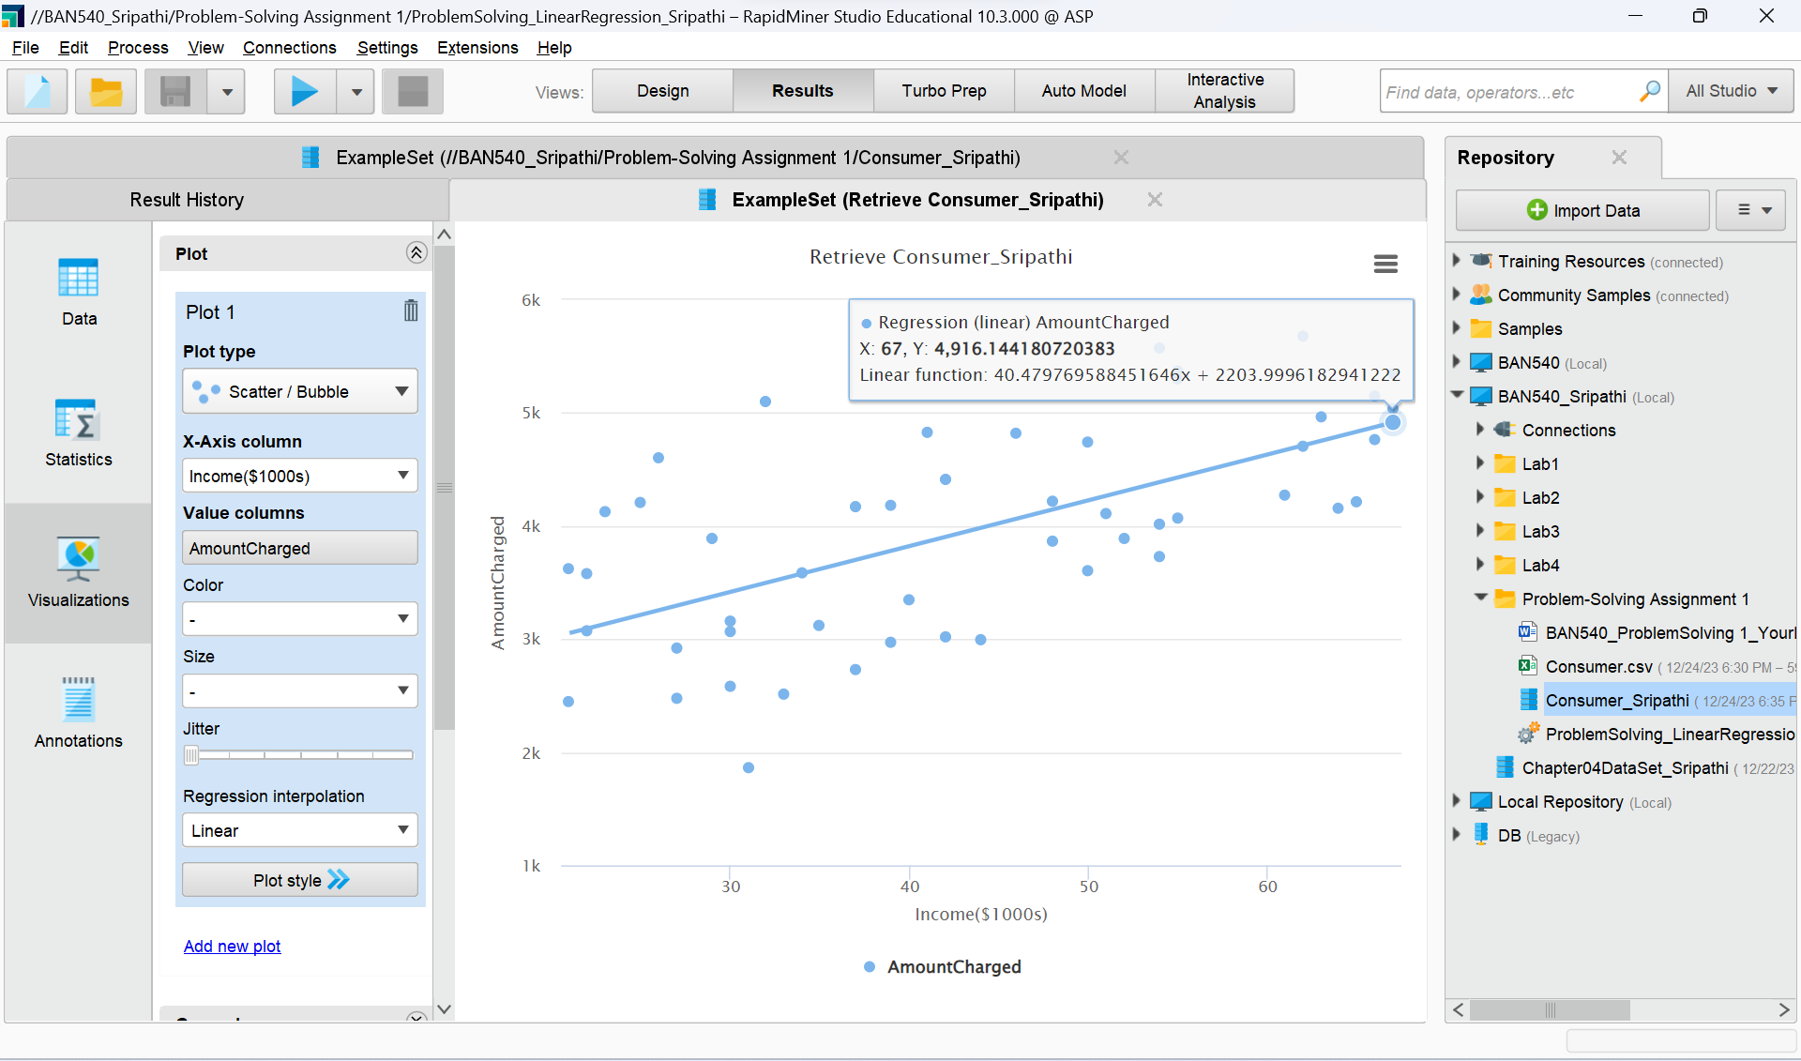

**Screenshot #3 (6 points)**

**Screenshot #4 (6 points)**

**Screenshot #5 (8 points)**

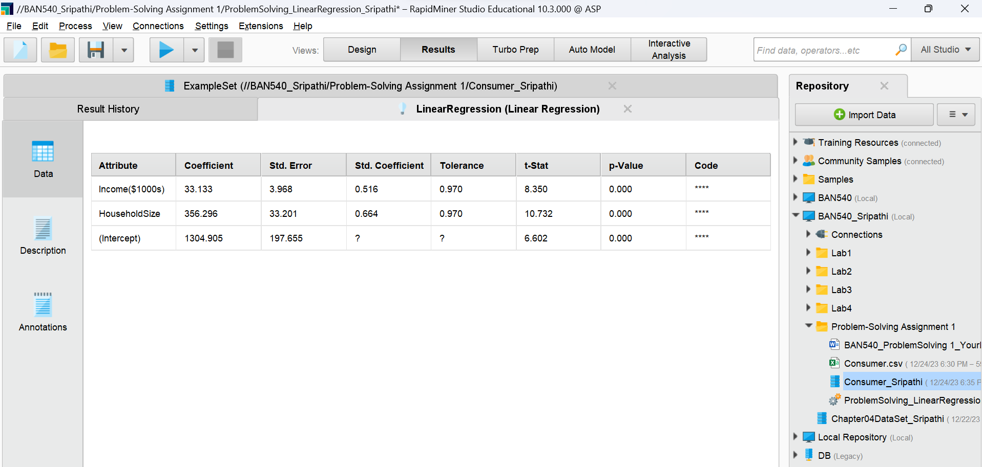

1. **Question (6 points)**: The formula for the multiple linear regression is (please fill in the blanks below):

**Answer:**

**Multiple Linear Regression Formula:**

Amount Charged = Income($1000s) * (**33.133**) + Household Size * (**356.296**) + (**1304.905**)  
  
The above formula is derived from the below:  
***Y*=*β*0​+*β*1​*X*1​+*β*2​*X*2​+*β3*​*X3*​+…….**

**Here, the dependent variable (Y) in this formula is the annual credit card bill, whereas the independent variables (X1, X2... Xn) are the household size, income, etc.**

(*Note*: Please keep 3 decimal places.)

1. **Question (6 points)**: What is the predicted annual credit card charge for a four-person household with an annual income of $50,000? (please type in your answer on the blank line below)

**Answer:**

A household's annual credit card bill can be predicted by using the multiple linear regression formula that has been provided. Here, we're thinking about a family of four that makes $50,000 a year. We determine each component by using the formula: multiplying the household size by its coefficient, multiplying the income by its coefficient, and adding the constant at the end. We calculate the expected yearly credit card bill to be roughly $4386.74 by adding these amounts together. This estimate is the estimated spending based on the size and income of the household and is based on the provided model.

=50*(33.133) + 4*(356.296) + (1304.905)

= 1656.65 + 1425.184+1304.905

= 4386.739

Amount Charged = 4386.74 (*Note*: Please keep 2 decimal places.)

1. **Question (6 points)**: What additional independent variables might be helpful to make better predictions of the annual credit card charge? Please name at least **two** variables and briefly explain why.

**Answer:**

**Consider these two more independent variables to improve annual credit card charge predictions:**

**Customer Income Level:** Stronger income levels are frequently associated with stronger purchasing power, which could result in higher credit card fees. Adding income as a variable could help understand how different income categories affect spending habits.

**Credit Score:** A consumer's credit score may serve as a predictor of their spending patterns and creditworthiness. A higher credit score generally indicates prudent credit management, which may be associated with credit card charge patterns.

**These factors might give the analysis important new dimensions and enable more precise and sophisticated forecasts of credit card usage trends.**

**Now you are done with Problem-Solving Assignment 1, please make sure to fill in your name on the first page of this document and rename this document to reflect your own last name before submitting it to Canvas.**